**LAB NO: 5**

**Inter-vlan switching using cisco packet tracer**

**Aim:**

To do the following:

1. Set up star topology using SWITCH.
2. Set VLAN for end devices
3. Transfer Message from one PC to another PC of same VLAN
4. Transfer Message from one PC to another PC of Another VLAN

**Software Required:**

CISCO Packet Tracer

**VLAN:**

A virtual LAN (VLAN) is a logical overlay network that groups together a subset of devices that share a physical LAN, isolating the traffic for each group. A VLAN, like the LAN it sits atop, operates at Layer 2 of the network, the Ethernet level. VLANs partition a single switched network into a set of overlaid virtual networks that can meet different functional and security requirements. This partitioning avoids the need to have multiple, distinct physical networks for different use cases.

**Simulating VLAN in Cisco Packet Tracer**

Step 1: Set up a network with some end-devices and a central network device. I have set up 8 PCs and a switch.

Connect the PCs to the Switch.

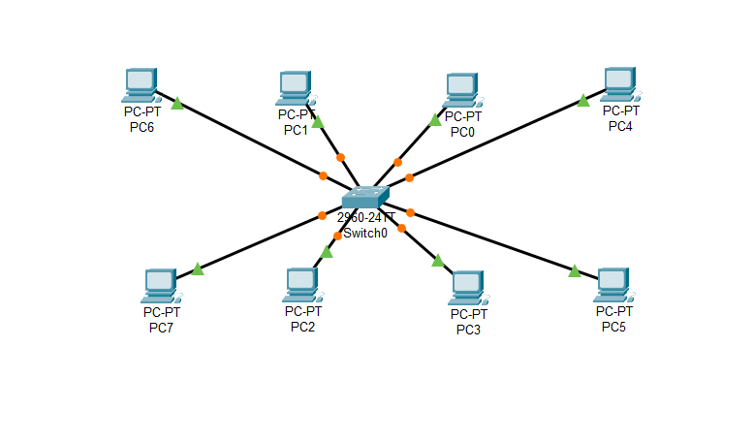

Step 2: Provide an IP address to each PC and divide the network into sections.

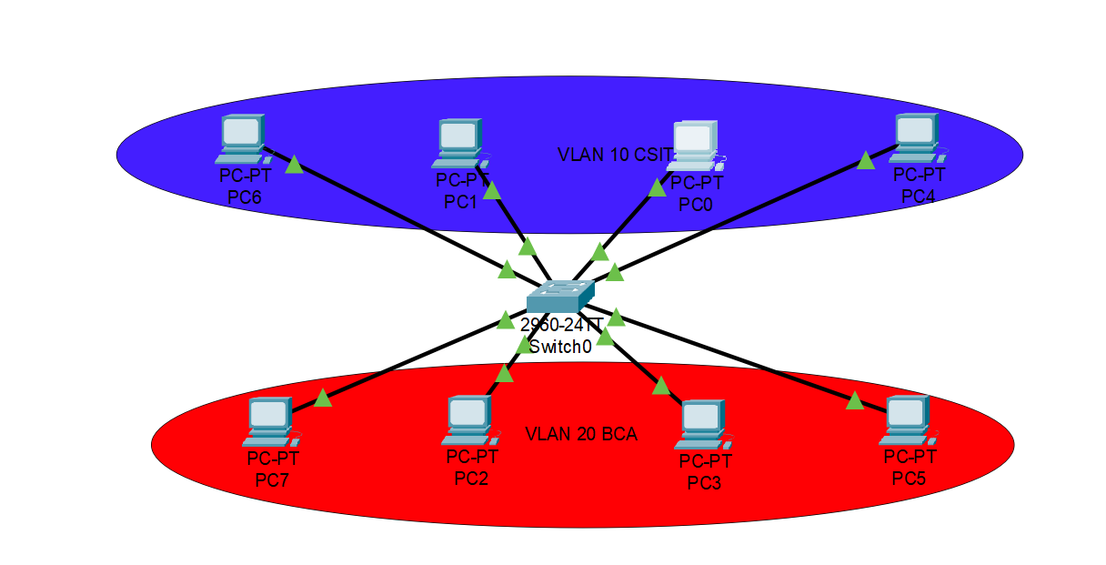

Step 3: Configure the VLAN database and add the required number of virtual LAN. I have added two VLAN as my network is divided into two separate networks. Configure the “Fast Ethernet” port for the PC in switch and specify the VLAN you want it to be in.

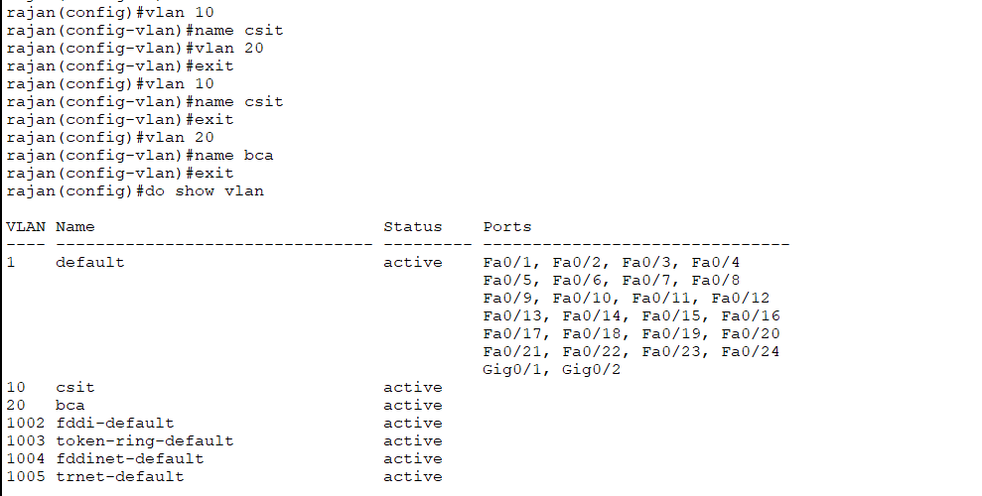

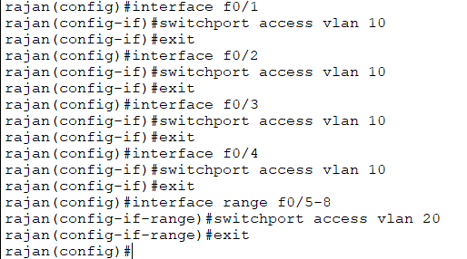

Step 4: Send packets between computer within same VLAN and different VLAN.

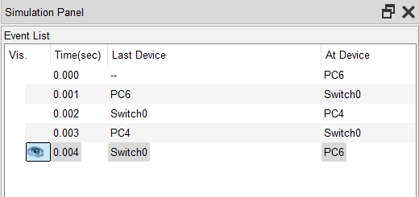

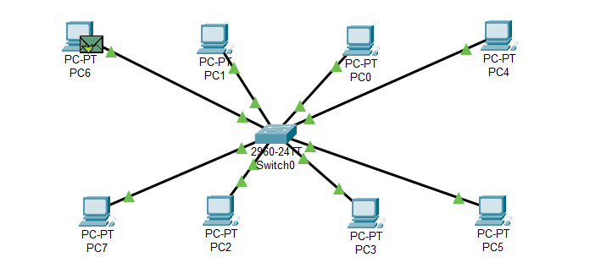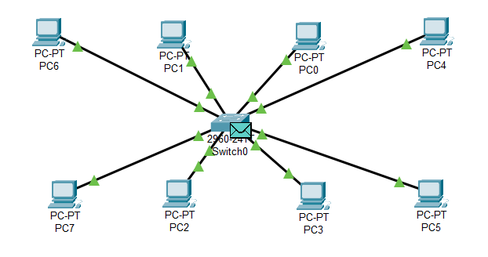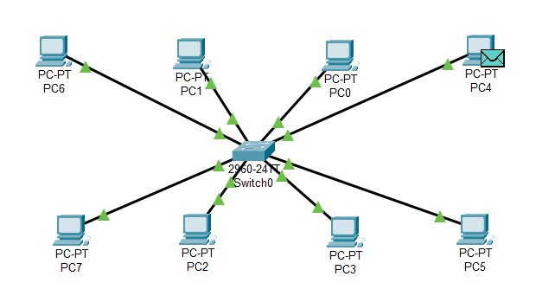

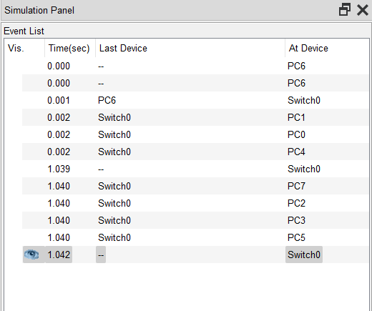

Step 5: Ping between computer within same VLAN and different VLAN.

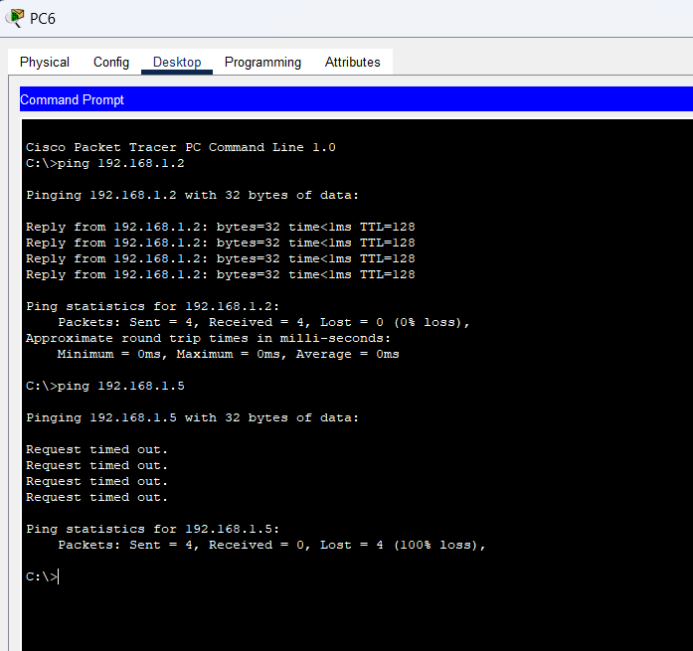

**Conclusion:**

Thus, VLAN switching using cisco packet tracer was done successfully.